

**TAYYABA REHMAN**

**49690**

**LAB 6**

**DATABASE SYSTEM**

**CODE:**

create database StudentDb;

USE StudentDb;

SHOW databases;

Show Tables;

CREATE table Student

(

Student_ID int primary key,

Email Varchar(50) unique,

Age Int,

Check (Age>=16),

classID INT,

FOREIGN KEY (ClassID) REFERENCES Class(ClassID)

);

Insert into Student

(Student_ID,Email,Age,ClassID)

values

(1,'tayyaba@gmail.com',21,11),

(2,'ayesha@gmail.com',19,22),

(3,'shafia@gmail.com',19,33),

(4,'amna@gmail.com',20,44),

(5,'fatima@gmail.com',20,55),

(6,'izza@gmail.com',20,66),

(7,'emaan@gmail.com',16,77),

(8,'areeba@gmail.com',22,88),

(9,'malaika@gmail.com',23,99),

(10,'anaya@gmail.com',21,1010);

SELECT * FROM Student;

CREATE TABLE Class (

ClassID INT PRIMARY KEY,

ClassName VARCHAR(100) UNIQUE,

ClassType VARCHAR(50) DEFAULT 'General'

);

Insert into Class

(ClassID,ClassName)

value

(11,'BSCS'),

(22,'SE'),

(33,'CA'),

(44,'PSYCOLOGY'),

(55,'DPT'),

(66,'MLT'),

(77,'ARTIFICIAL INTELLEGENCE'),

(88,'CYBER SECURITY'),

(99,'MECHANICAL ENGINEERING'),

(1010,'ENGINNERING');

SELECT * FROM Class;

Select

Constraint_name,

Constraint_type

FROM

information_schema.Table_constraints

where

table_name = "Student";

Alter table Class

Drop Index ClassName;

CREATE table Employee

(

Emploee_ID int primary key,

Emaill Varchar(50) unique,

Salary Int,

Check (Salary BETWEEN 50000 AND 200000),

Department_ID INT,

FOREIGN KEY (Department_ID) REFERENCES Department(Department_ID)

);

Insert into Employee

(Emploee_ID,Emaill,Salary,Department_ID)

values

(1,'tayyaba@gmail.com',200000,11),

(2,'ayesha@gmail.com',50000,22),

(3,'shafia@gmail.com',60000,33),

(4,'amna@gmail.com',70000,44),

(5,'fatima@gmail.com',80000,55),

(6,'izza@gmail.com',90000,66),

(7,'emaan@gmail.com',100000,77),

(8,'areeba@gmail.com',110000,88),

(9,'malaika@gmail.com',120000,99),

(10,'anaya@gmail.com',130000,1010);

SELECT * FROM Employee;

CREATE TABLE Department (

Department_ID INT PRIMARY KEY,

Department_Name VARCHAR(100) UNIQUE,

Location VARCHAR(50) DEFAULT 'Head Quarters'

);

Insert into Department

(Department_ID,Department_Name)

value

(11,'HR'),

(22,'FINANCE'),

(33,'MARKETING'),

(44,'IT'),

(55,'SALES'),

(66,'R & D'),

(77,'CUSTOMER SUPPORT'),

(88,'LEGAL'),

(99,'OPERATIONS'),

(1010,'PRECUREMENT');

SELECT * FROM Department;

ALTER TABLE Employee DROP CONSTRAINT employee_chk_1;

ALTER TABLE Employee ADD CONSTRAINT employee_chk_1_new CHECK (Salary BETWEEN 30000 AND 250000);

ALTER TABLE Employee DROP FOREIGN KEY employee_ibfk_1;

ALTER TABLE Employee ADD CONSTRAINT employee_ibfk_1 FOREIGN KEY (Department_ID) REFERENCES Department(Department_ID);

ALTER TABLE Student CHANGE Email StudentEmail VARCHAR(50);

ALTER TABLE Student CHANGE Age AGES INT;

ALTER TABLE Class CHANGE ClassName CourseName VARCHAR(25);

ALTER TABLE Class CHANGE ClassType CourseType VARCHAR(20);

INSERT INTO Class (ClassID, CourseName, CourseType)

VALUES

(1111, 'Maths', 'Lecture');

INSERT INTO Student (Student_ID, StudentEmail, AGES, ClassID)

VALUES

(11, 'student3@example.com', 15, 1111);

**TASKS:**

**Task 1:**

**1.** List all databases using an appropriate SQL query.

SHOW databases;

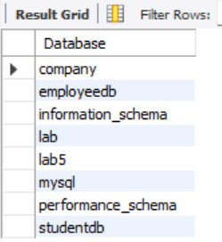

**2.** List all tables in the selected database (e.g., StudentDB).

Show Tables;

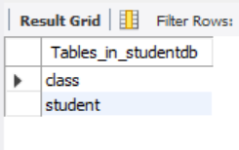

**3.** Check field constraints in the Student table, listing all columns and their constraints (such as NOT NULL, UNIQUE, PRIMARY KEY).

Select

Constraint_name,

Constraint_type

FROM

information_schema.Table_constraints

where

table_name = "Student";

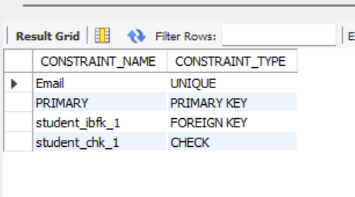

**Task 2: Student and Class Table Constraints**

**TASKS:**

1. Create both tables with the constraints mentioned above.

**Student Table:**

CREATE table Student

(

Student_ID int primary key,

Email Varchar(50) unique,

Age Int,

Check (Age>=16),

classID INT,

FOREIGN KEY (ClassID) REFERENCES Class(ClassID)

);

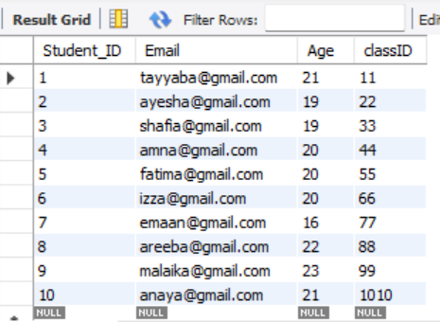

**Class Table:**

CREATE TABLE Class (

ClassID INT PRIMARY KEY,

ClassName VARCHAR(100) UNIQUE,

ClassType VARCHAR(50) DEFAULT 'General'

);

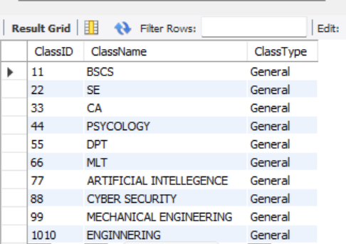

1. Insert sample data:

o Insert valid student and class records.

 

o Insert a student under 16 years of age to test the check constraint.

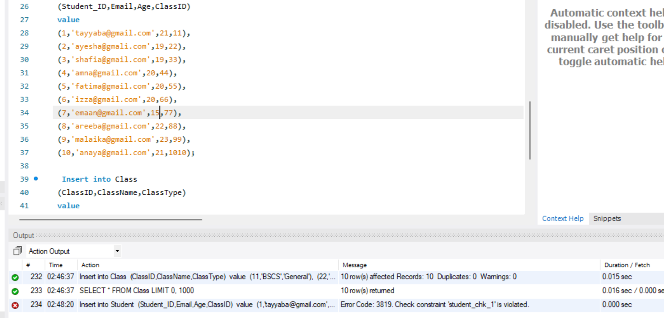

1. Modify the ClassName constraint to allow duplicate class names (remove the unique constraint).

**CODE:**

Alter table Class

Drop Index ClassName;

**Task 3: Employee and Department Table Constraints**

**TASKS:**

1. Create both tables with the constraints mentioned above.

**Employee Table:**

CREATE table Employee

(

Emploee_ID int primary key,

Emaill Varchar(50) unique,

Salary Int,

Check (Salary BETWEEN 50000 AND 200000),

Department_ID INT,

FOREIGN KEY (Department_ID) REFERENCES Department(Department_ID)

);

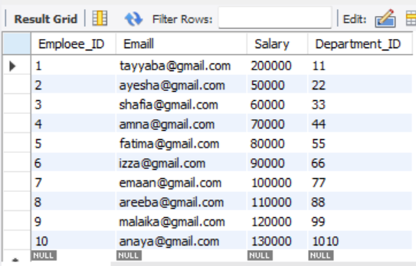

**Department Table:**

CREATE TABLE Department (

Department_ID INT PRIMARY KEY,

Department_Name VARCHAR(100) UNIQUE,

Location VARCHAR(50) DEFAULT 'Head Quarters'

);

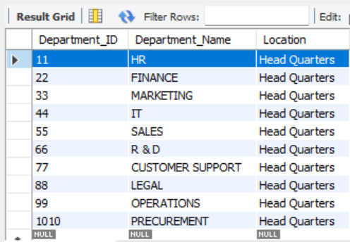

1. Insert sample data:

o Insert valid employee and department records.

 

o Insert an employee with a salary outside the valid range to test the check constraint.

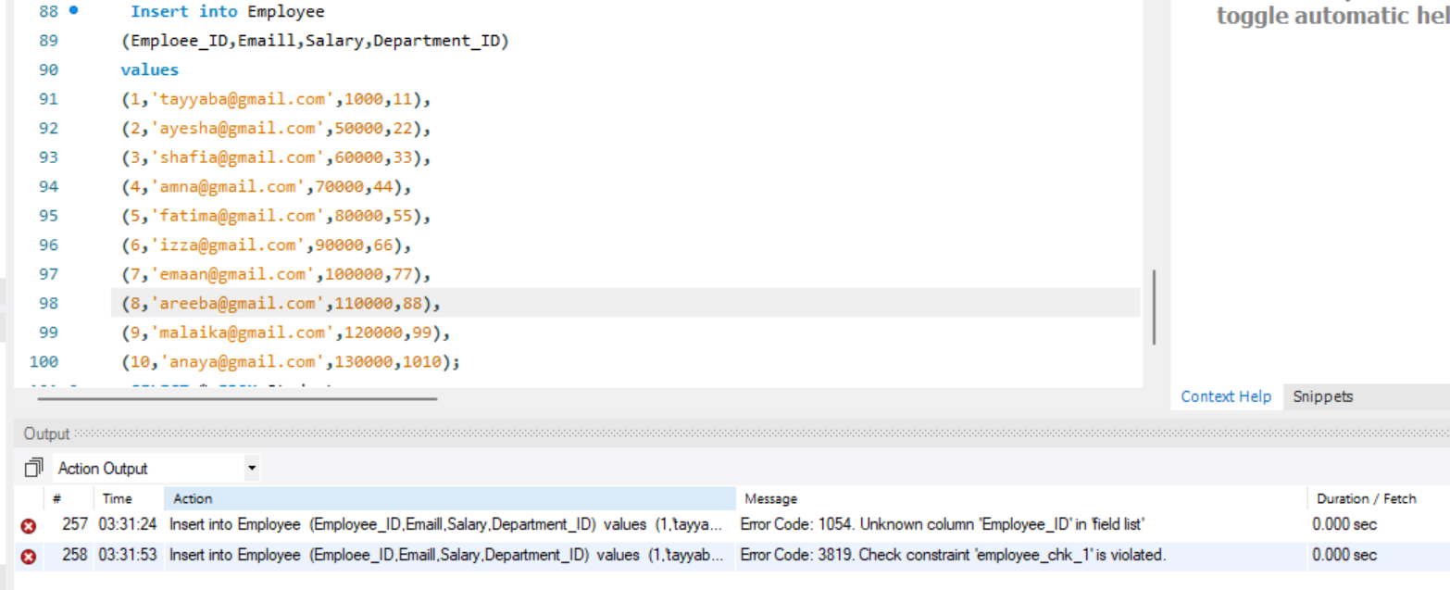

1. Modify the salary range to allow salaries between 30,000 and 250,000

ALTER TABLE Employee DROP CONSTRAINT employee_chk_1;

ALTER TABLE Employee ADD CONSTRAINT employee_chk_1_new CHECK (Salary BETWEEN 30000 AND 250000);

1. Modify primary key and foreign key

ALTER TABLE Employee DROP FOREIGN KEY employee_ibfk_1;

ALTER TABLE Employee ADD CONSTRAINT employee_ibfk_1 FOREIGN KEY (Department_ID) REFERENCES Department(Department_ID);

**Task 3: Modify Column Names in Existing Tables**

1. Rename the columns in both the Student and Class tables according to the new requirements.
2. **Student Table:**

o **The current Email column should be renamed to StudentEmail.**

ALTER TABLE Student CHANGE Email StudentEmail VARCHAR(50);

**o The Age column should be renamed to AGES.**

ALTER TABLE Student CHANGE Age AGES INT;

1. **Class Table:**

o **The current ClassName column should be renamed to CourseName.**

ALTER TABLE Class CHANGE ClassName CourseName VARCHAR(25);

o **The ClassType column should be renamed to CourseType.**

ALTER TABLE Class CHANGE ClassType CourseType VARCHAR(20);

**Tasks:**

1. Verify the changes by checking the updated column names.

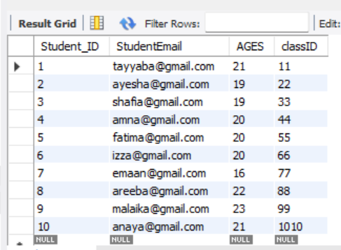

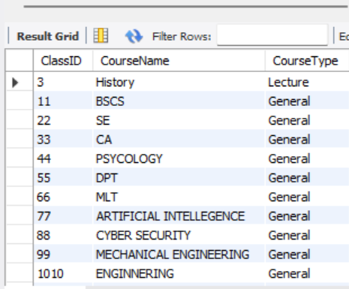

1. Test the updated table structure by inserting a new student and class record.

INSERT INTO Class (ClassID, CourseName, CourseType)

VALUES

(1111, 'Maths', 'Lecture');

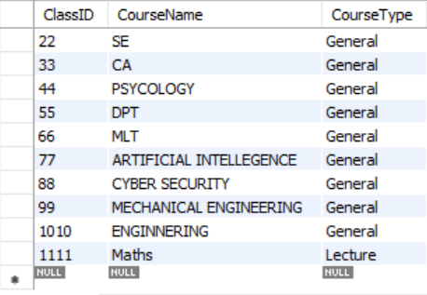

INSERT INTO Student (Student_ID, StudentEmail, AGES, ClassID)

VALUES

(11, 'student3@example.com', 15, 1111);

